The "bog dress" or "bog gown" is one of the most widely-made types of basic garb in the SCA (after only the T-tunic). If you have been to a summer SCA event before, you have probably learned what a "bog dress" is. It's part of an SCA cultural tradition that goes back decades, and because many bog dresses are of questionable historical consistency, they are most often used as newcomer garb, or as informal camp or work garb.
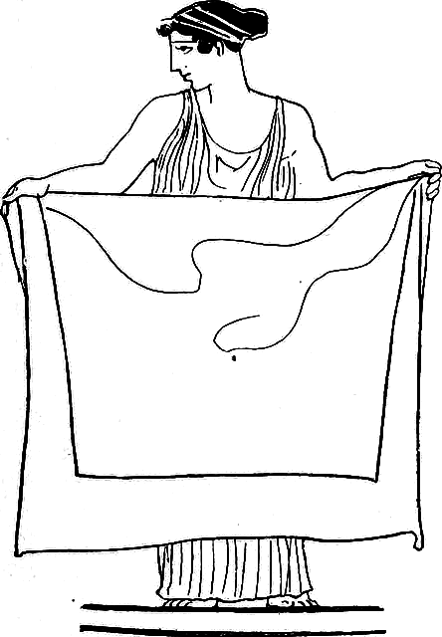
An SCA bog dress is a simple sleeveless wrap or tube dress, similar to a Greek chiton or Roman stola. It is very simple and inexpensive to make, adaptable to most body types, and cool for summer weather. The name “bog dress” derives from the garb found preserved in a bog in Huldremose, Denmark, in the 1890s. This dates from the early Iron age, much earlier than the SCA period. However, evidence exists of garb in a similar style worn at least occasionally in many cultures in Europe throughout the SCA period, including Ireland, England, Scandinavia, Finland, and Latvia. There were also Ancient Rome re-enactors in period! (You may sometimes see “bog dress” used for fitted garb derived from bog bodies, but in the SCA it usually means the peplos type.)
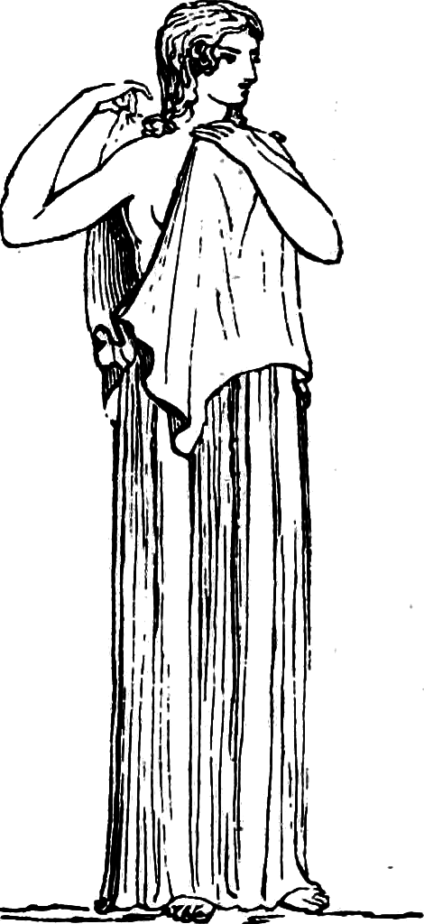
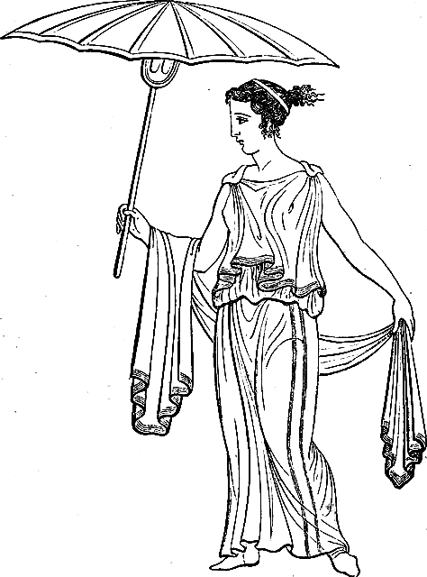
The simplest form of this garment is a rectangle of cloth wrapped around the body, pinned at the shoulders, and belted to hold it in place at the waist. It can be any length from a waist-length “blouse” to an ankle-length gown, and could have been worn at times by men as well as women and children. Sometimes the rectangle of cloth is sewn up the side to make a cylinder, sometimes it is left open on one side. Sometimes there is a flap folded over the shoulders. They may be pinned on one shoulder, both shoulders, with a extra pin in the center front, or with multiple fastenings down the arms. There is some evidence of early Norse examples with straps over the shoulders, blurring into the classic Viking apron dress.
Unlike the apron dress, the bog dress should be very full, allowing for lots of drape and overlap. Bog dress type gowns would most likely have been worn over some kind of underdress, but in most examples, the underclothing is unknown, so for Pennsic heat purposes we are free to improvise.
Because it’s one uncut length of cloth, a bog dress is endlessly adaptable. It adjusts to changes in body shape and can also be used as a blanket, tablecloth, sunshade, towl, kilt, cloak, etc.; or later recut into a fitted gown. This may help explain its enduring popularity.
THE BASIC NO-SEW, NO-CUT BOG DRESS
MATERIALS
-A rectangle of fabric that is somewhere between the wearer’s calf-to-shoulders measurement and just over their full height (depending on desired length and the amount you will fold it over.) For average adult women, 2-5 yards of 54” to 72” cloth will do.
Use natural fibers if you can get them. Wool, cotton and linen will do fine. If you’re using synthetics, make sure they’re breathable. Use fabrics that are light, cool, and drape easily. For a Celtic look, go for loud checks, plaids, and stripes, clashing if possible. For a medieval Norse look, try twill in a muted blue (think denim.) In general look for solid colors or woven-in patterns rather than prints—it’s more period, and the back of the fabric will be visible. Look in thrift stores, bargain bins, etc.
-Two pins or brooches. Large safety pins will do in a pinch. They need to be fairly heavy-duty – they will be taking a lot of strain! Also acquire some sort of belt – a ring-belt, a length of trim, or a cord long enough to tie around the waist are all fine.
-Depending on your flexibility, a helper.
ASSEMBLY
- Hold the cloth up to your body and fold the top edge down far enough to get the desired length. (If cloth is narrow, you can skip this step.)
- Wrap the cloth around your body, and then pull both ends to one side until you have the cloth folded approximately in half, with the fold line on one side of the body. Press that arm down to hold it in place.
- Pull the cloth up around that shoulder, making it loose enough for easy movement, and pin in place over the shoulder. It is OK if the fabric goes a bit uneven in the process.
- Pin the other shoulder. Wriggle around until you feel like there’s a good range of motion.
- Wrap both ends of the fabric around your body so that they are well-overlapped, tucking the front inside the back, and fasten the belt as tightly as is comfortable over them. Pull some of the fabric up through the belt to create a bloused look at the waist and provide room for movement.
- If things seem precarious, uncomfortable, or weird, adjust as necessary.
- When taking off the gown, unfasten the belt and unpin the pin on the open side, then slide off, leaving the first pin in place. This makes it much easier to put on next time.
- If you are using a single piece of cloth off the bolt, the top and bottom edges should already be finished, but the ends will not be. For occasional use, it’s fine to leave the edges unfinished – if it’s a woven-in pattern, it will fray into a striped fringe with time; wool will felt itself. However, a simple rolled hem, a line of woven trim, or even fray-check will work to protect the edge if the garment will be worn a lot. Medieval people would have used fray-check if they had it.

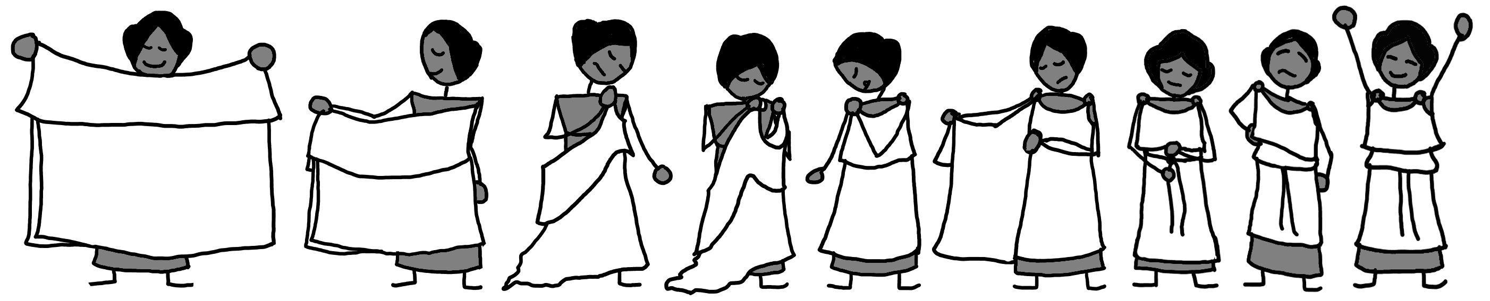

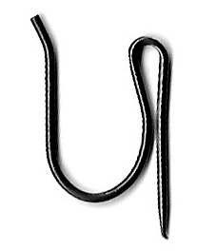
Make Your Own Fibulae : The Cheapskate Way
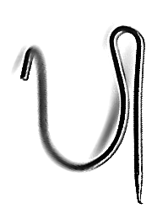
Get some small drapery hooks/curtain pins. Bronze if you can get them, but other metals will also work. You should be able to bay a couple bucks a bag at a hardware or home store, or you may have some in a junk drawer already.
Get one or two pairs of small needle-nose pliers. Use them to bend to non-pointy end into a small U-shaped hook.
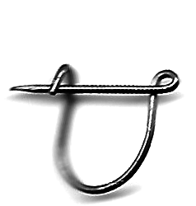
Then take the pointy end and pull it forward about 90 degrees, so it makes a circle where it joins the pin, and the pointy end is near the hook you just made.
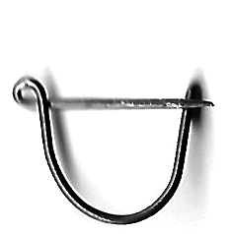
If you bend the pointy end up in front of the hook, it will be easier to pin, but less secure. If you bend it behind the hook, vice versa.
Ta-da! You have now made your own fibula.
The shape can be changed by changing the bend in the wire. You can also use a ball-been hammer and anvil to hammer the non-pointy end flat before you bend it, if you would like a slightly different look.
Make Your Own Fibulae : The Cheapskate Way
Get some small drapery hooks/curtain pins. Bronze if you can get them, but other metals will also work. You should be able to bay a couple bucks a bag at a hardware or home store, or you may have some in a junk drawer already.
Get one or two pairs of small needle-nose pliers. Use them to bend to non-pointy end into a small U-shaped hook.
Then take the pointy end and pull it forward about 90 degrees, so it makes a circle where it joins the pin, and the pointy end is near the hook you just made.
If you bend the pointy end up in front of the hook, it will be easier to pin, but less secure. If you bend it behind the hook, vice versa.
Ta-da! You have now made your own fibula.
The shape can be changed by changing the bend in the wire. You can also use a ball-been hammer and anvil to hammer the non-pointy end flat before you bend it, if you would like a slightly different look.

